**Report of TD 3 FingerPrint**

Positioning Systems techniques and Applications Master 1,

International Master 1 -Internet of Things

The University of Franche-Comté

### By: Uendi MUCA and Omar KHALIL

### Submit To: Dr. Phillipe CANALDA

### Date:27.03.2025

Table of Contents

1.Introduction to FingerPrint

2.Introduction to K-nearest

3.Problem Introduction

4.Mathematical problem

5.Conceptualization of the Problem

6.Architecture of program

7.Class Diagram

8.Data Structure

9.Pseudo-Code

10.Algorithm

11.Mathematical Calculations

12.Comparison of code results and theoretically computed results

13.Conclusions

### **Introduction to Fingerprint-Based Positioning**

Fingerprint-based positioning is a **localization method** used to estimate the coordinates of an unknown point (mobile device) based on **pre-collected signal measurements** (RSSI values) from known reference locations. This technique is widely used in **indoor positioning** where traditional GPS signals are weak or unavailable, such as in malls, airports, or underground facilities.

Unlike lateration methods (such as **N-Lateration**), which rely on **geometric distance calculations**, fingerprinting is based on **pattern matching** by comparing real-time received signals to a pre-recorded database of signal strengths from different access points.

Fingerprint-based localization operates in two main phases:

#### **1. Offline Phase (Fingerprint Collection)**

* 1. A **radio map** is created by measuring **RSSI (Received Signal Strength Indicator)** from multiple known reference locations (cells).
  2. The fingerprint database is stored, associating each reference position with the **RSSI vector** from multiple transmitters (WiFi APs, Bluetooth beacons, etc.).
  3. The recorded dataset consists of: Reference Location(xi,yi)→RSSI Vector

**2. Online Phase (Position Estimation)**

* The mobile device measures real-time **RSSI values** from available reference signals.
* The system compares this new measurement with the stored fingerprint database and selects **k-nearest reference points** based on RSSI similarity.
* The estimated position is computed using a **weighted averaging method**, where reference points with closer RSSI values contribute more to the final position.x

# 

# **Introduction to K-Nearest Neighboring**

The **K-Nearest Neighbor (KNN) approach** in fingerprint-based localization is a method used to estimate the position of a mobile terminal by comparing its **Received Signal Strength Indicator (RSSI)** values with a predefined database of reference points. In this method, a set of locations with known coordinates (reference points) and their associated RSSI values are stored. When a mobile device measures its RSSI values in real-time, the algorithm **computes the difference** between the measured RSSI and the stored RSSI values for each reference point.

The algorithm then **sorts the reference points** based on their similarity to the measured RSSI and selects the **k-nearest** reference points that have the smallest RSSI difference. These selected points contribute to estimating the mobile device's position. The final estimated position is obtained using a **weighted average**, where closer reference points (with lower RSSI differences) have higher weights, ensuring a more precise localization.

By using **KNN with RSSI-based weighting**, the algorithm provides a robust way to estimate the mobile terminal’s position while considering multiple signal sources, minimizing errors caused by fluctuations in signal strength.

# 

# **Problem Introduction**

The goal of this code is to **estimate the position** of a **mobile terminal (MT)** within a predefined **square area** by utilizing a set of **reference points (cells)** with known locations and their recorded **Received Signal Strength Indicator (RSSI) values** from multiple transmitters.

### 

### 

### 

### 

### **Mathematical Model**

Instead of solving distance-based nonlinear equations like **N-Lateration**, fingerprinting uses an **RSSI-based similarity approach**:

1. **Find k-Nearest Neighbors:**
   * Compute the absolute RSSI difference for each reference position: di​=∑∣ri,j​−rtm​∣
   * where:
     + ri,j​ is the stored RSSI from reference point i for transmitter j.
     + rtm is the RSSI data of terminal mobile.
     + di​ represents the RSSI difference between the mobile device and reference point i.
2. **Weight Calculation (Inverse Distance Weighting - IDW):**
   * Assign weights based on inverse RSSI difference:wi​=d1/di​, for di​ != 0
   * Normalize weights: wi′​=wi/∑wi​
3. **Estimate the Mobile Position:**
   * Compute the weighted average of k-nearest reference points: x^=∑wi′​xi​ ,y^​=∑wi′​yi​

* Where the coordinates of the reference positions.

## **Conceptualization of the Problem**

The **Fingerprinting-based positioning algorithm** is used to estimate the position of a receiver (**mobile terminal**) based on **RSSI (Received Signal Strength Indicator) values** from multiple **reference points (WiFi APs, Bluetooth Beacons, or known locations)**.

Unlike **N-Lateration**, which relies on **distance measurements**, **fingerprinting** compares the **RSSI patterns** of a mobile device to a **pre-recorded fingerprint database** and estimates the **most likely position** using RSSI similarity.

Process of RSSI-based Fingerprint Positioning:

1. **Offline Phase:** A database of **RSSI values** is collected at known reference positions (cells).
2. **Online Phase:** The mobile device records **live RSSI values** and compares them to the **pre-recorded database** to estimate the position.
3. **Position Estimation:** The system finds the **k-nearest reference points** (RSSI similarity) and calculates the estimated position using **weighted averaging**.

Data set input:

|  |  |  |
| --- | --- | --- |
| Cell i | Reference Location (x, y) (meters) | RSSI Vector [r1​,r2​,r3​,r4​] |
| 0 | (0,0) | [-38, -27, -54, -13] |
| 1 | (4,0) | [-74, -62, -48, -33] |
| 2 | (8,0) | [-13, -28, -12, -40] |
| 3 | (0,4) | [-34, -27, -38, -41] |
| 4 | (4,4) | [-46, -48, -72, -35] |
| 5 | (8,4) | [-45, -37, -20, -15] |
| 6 | (0,8) | [-17, -50, -44, -33] |
| 7 | (4,8) | [-27, -28, -32, -45] |
| 8 | (8,8) | [-30, -20, -60, -40] |

The **mobile terminal (MT)** is located at an **unknown position** and measures the following **RSSI values**:

TM RSSI=[−26,−42,−13,−46]

**Architecture and program flow**

The purpose of this program is to estimate the position of a mobile terminal (receiver) based on the **Received Signal Strength Indicator (RSSI)** values from multiple reference points using **RSSI-based fingerprinting**. The program is implemented in Python and follows a structured approach for data processing, selection of k-nearest reference points, and weighted positioning estimation.

### **Requirements:**

* **Programming Language:** Python 3 or above.
* **Libraries:** NumPy for numerical computations and data handling.
* **IDEs:** VS Code is used as the primary development environment, but any Python-compatible IDE can be used.

### **Design of the Program**

The program consists of three main components:

1. **Cellule Class (Reference Points Storage)**
   * Stores the **(x, y) coordinates** of each reference point.
   * Stores the associated **RSSI values** for that location.
   * Provides a method to access RSSI values for comparison.
2. **RSSI-Based Fingerprinting Algorithm**
   * The **fingerprint_localization function** compares the real-time RSSI values from the mobile terminal with stored RSSI values in the reference database.
   * It computes the **absolute difference** between the RSSI vectors of the mobile terminal and each reference point.
   * The reference points are **sorted by similarity**, and the **k-nearest points** with the lowest RSSI difference are selected.
3. **Weighted Position Estimation**
   * The selected **k-nearest points** contribute to estimating the position.
   * A **weighting function** is applied based on the RSSI difference, where points with a smaller difference contribute more to the estimated location.
   * The estimated **(x, y) coordinates** of the mobile terminal are computed as a **weighted average** of the selected reference points.

**Class diagram**

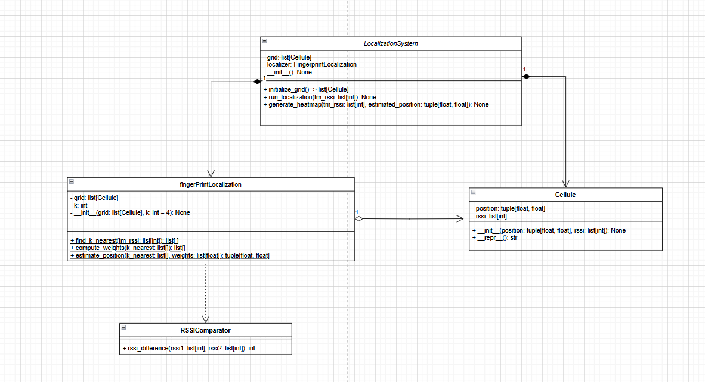

The LocalizationSystem class composes both FingerprintLocalization and Cellule, meaning it directly creates and owns the list of Cellule reference points and the localization engine their lifecycles are managed by the system. FingerprintLocalization aggregates Cellule, using a list of them to perform computations like finding the k-nearest neighbors and estimating position, but without owning or creating them itself. Additionally, FingerprintLocalization depends on RSSIComparator, calling its static method rssi_difference() to compare RSSI vectors during the localization process; this is a temporary usage and not part of its internal structure. These relationships show a clear separation of responsibilities while maintaining tight integration where needed for execution

### **Data Structure**

1. **Lists (list)**: Used to store multiple values, such as RSSI readings for each reference point and k-nearest neighbors in the localization process.
2. **NumPy Arrays (np.array)**: Used for efficient mathematical operations, such as normalizing weight calculations for position estimation.
3. **Objects (Classes)**: Encapsulate data and methods, organizing the program into **Cellule** (stores reference points), **RSSIComparator** (computes RSSI differences), **FingerprintLocalization** (handles the localization algorithm), and **LocalizationSystem** (orchestrates the overall process).
4. **Tuples (tuple)**: Used to store immutable data like the coordinates (x, y) of each fingerprint reference point.

**Pseudo code**

**CLASS Cellule:**

INIT(position, rssi): store position and rssi

REPR(): return string representation

**CLASS RSSIComparator:**

rssi_difference(rssi1, rssi2): return sum of absolute differences

**CLASS FingerprintLocalization:**

INIT(grid, k=4)

find_k_nearest(tm_rssi):

For each cell in grid:

compute RSSI diff → store (diff, position)

Sort by diff, return first k

compute_weights(k_nearest):

For each (dist, pos):

weight = 1/dist if dist ≠ 0 else 1

Normalize weights to sum to 1

Return weights

estimate_position(k_nearest, weights):

Weighted average of x and y using weights

Return (estimated_x, estimated_y)

**CLASS LocalizationSystem:**

INIT(): create grid and FingerprintLocalization

initialize_grid(): return list of Cellule with known positions/RSSI

run_localization(tm_rssi):

Get k_nearest → weights → estimated position

Print result

**MAIN:**

Create LocalizationSystem

Define tm_rssi (terminal's RSSI)

Call run_localization(tm_rssi)

**Algorithm**

The RSSI-Based Fingerprint Localization algorithm is used to estimate the position of a mobile terminal based on received signal strength (RSSI) values from multiple reference points. The algorithm involves identifying the k-nearest reference points by minimizing the RSSI difference between the measured signal strength of the mobile terminal and the stored fingerprint data.

**Source code documentation:**

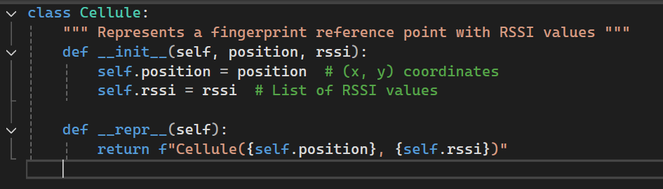

* This class is **only a data holder**; it does not contain logic or computations.
* Each Cellule object represents a **fixed reference point** in the environment with known RSSI values, which will later be compared with the mobile terminal’s RSSI during localization.

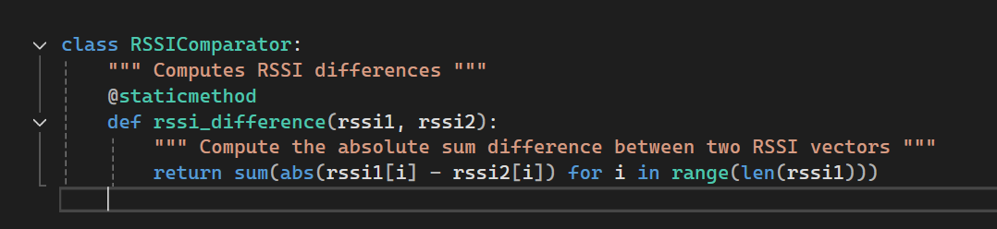

* This class is designed to provide a method for comparing two sets of RSSI values, typically used in fingerprint-based localization to determine the similarity between the signal strengths of a reference point and a mobile terminal.

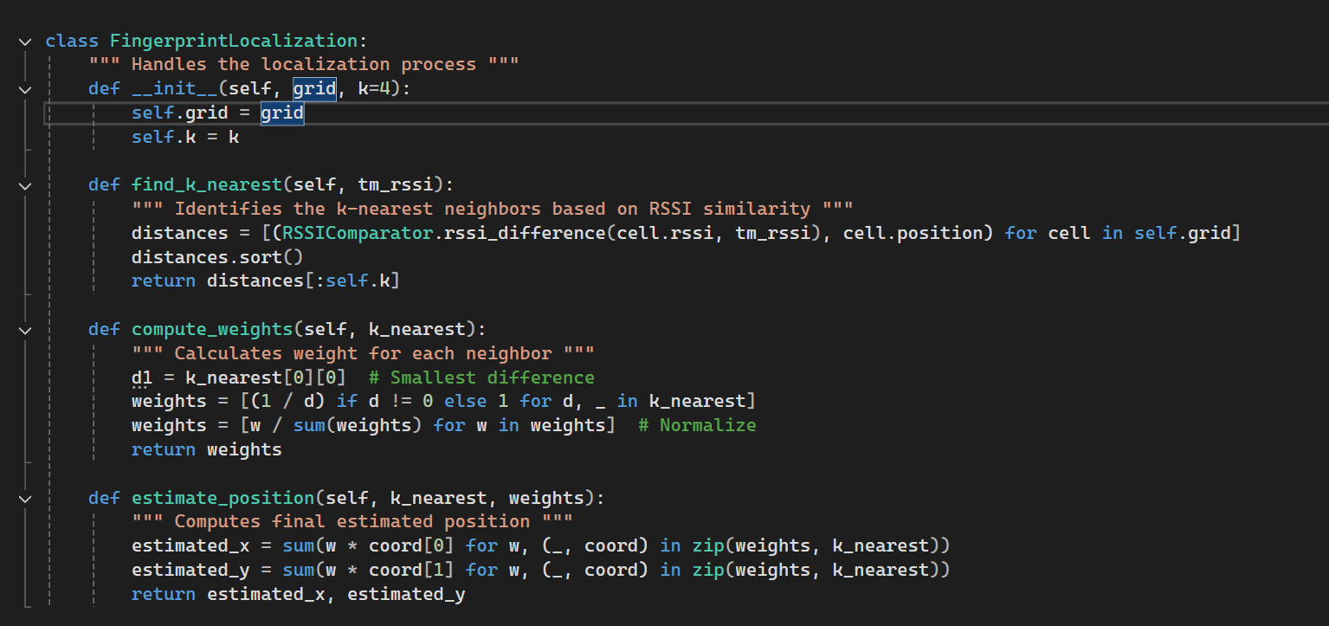

* Handles the localization process using fingerprint-based RSSI similarity.
* Computes the RSSI difference between the mobile terminal and each reference point.
* Returns the top k closest neighbors.
* Assigns weights inversely proportional to the RSSI difference.
* Normalizes weights so they sum to 1.
* Computes the estimated position as a weighted sum of the k-nearest neighbors’ coordinates.

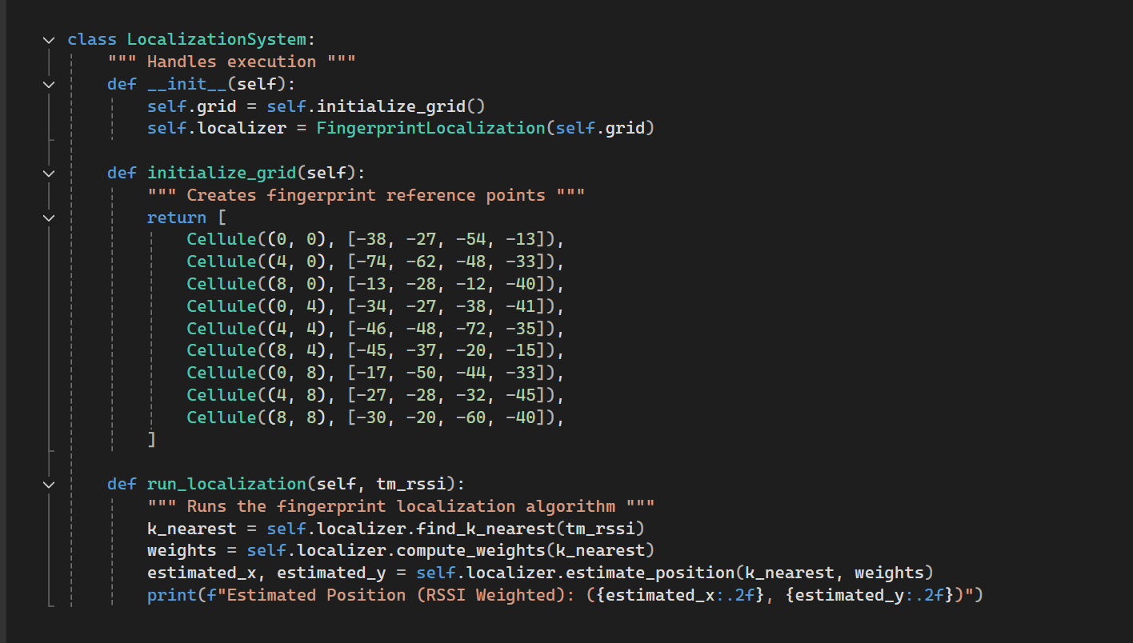

* This class is responsible for executing the fingerprint-based localization process.
* Defines a list of Cellule objects, each representing a known reference point with its position (x, y) and corresponding RSSI values.
* Uses estimate_position() to calculate the estimated location based on weighted contributions from the nearest reference points.
* Prints the final estimated position.

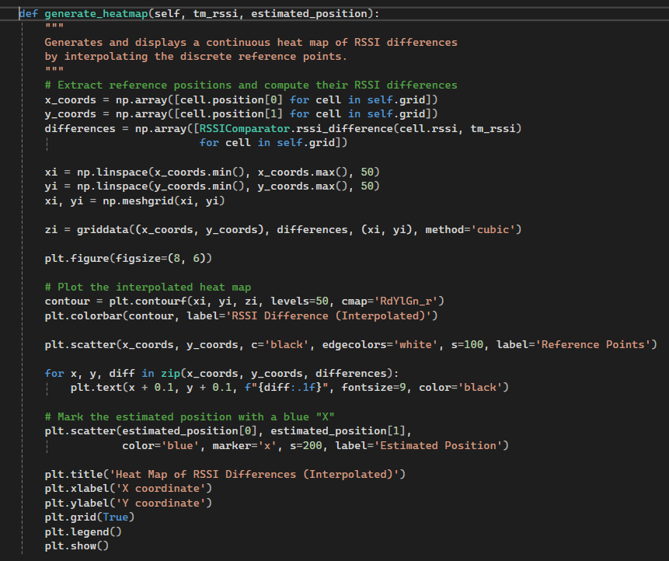

Also added this part for simple heat path generation based on our RSSI/coordinates data

Results:  
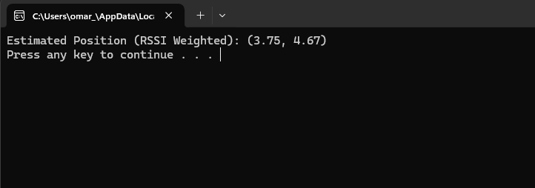

Heatmap:

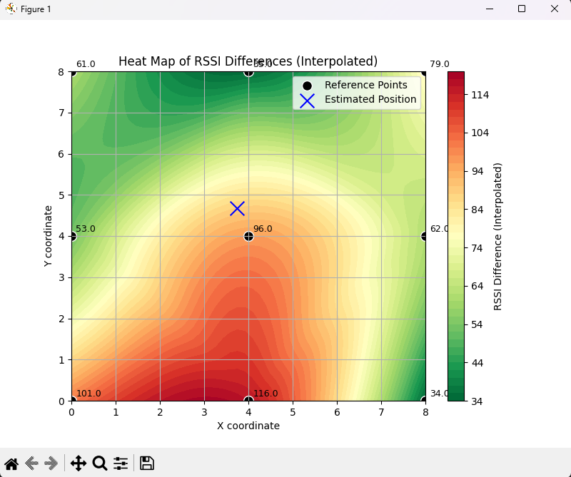

* Green is the best signal, degrading into red which is the worst signal
* The less is the RSSI difference between points the better the signal is

## **Comparison between theoretical and code**

In this part we will prove our code results using theories and applying the rules that we used in our code:

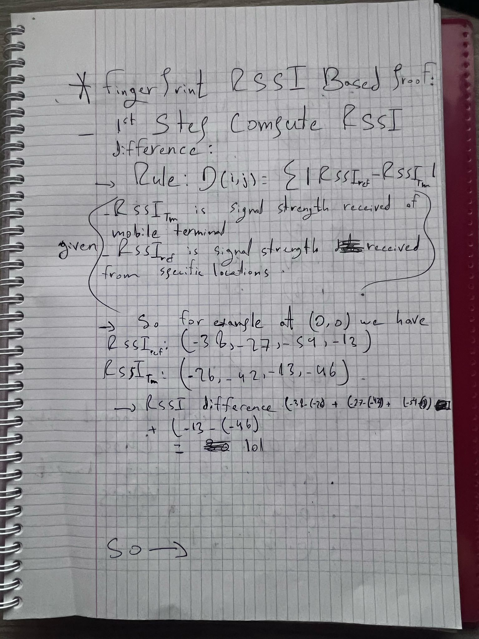

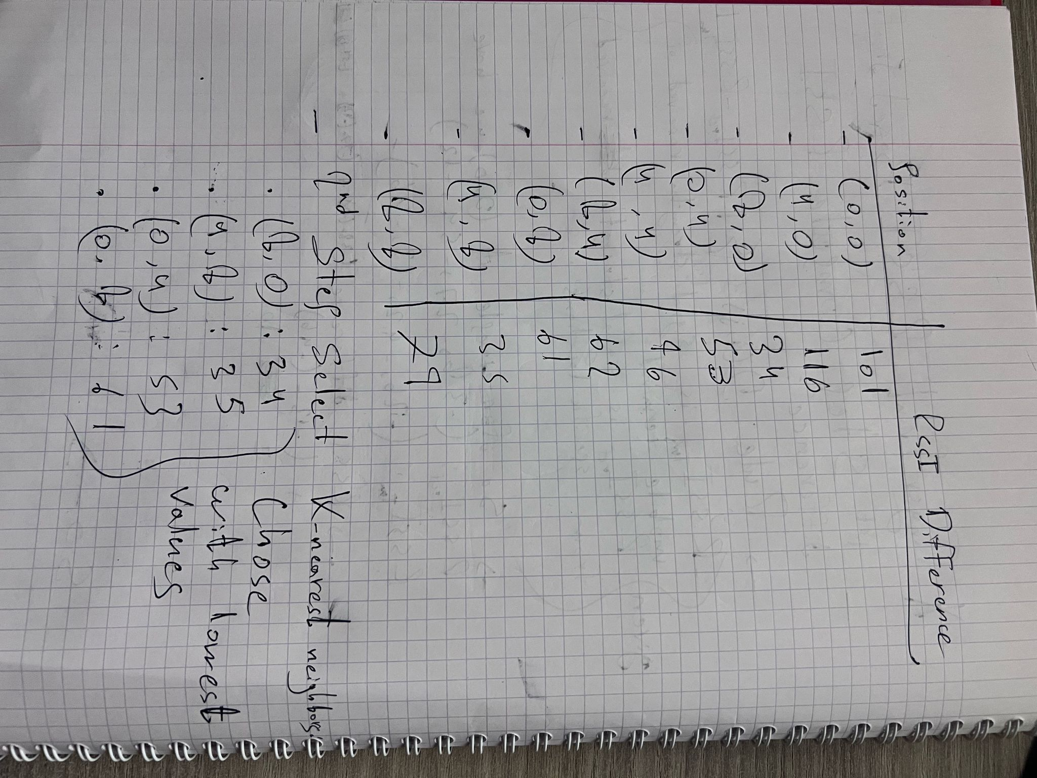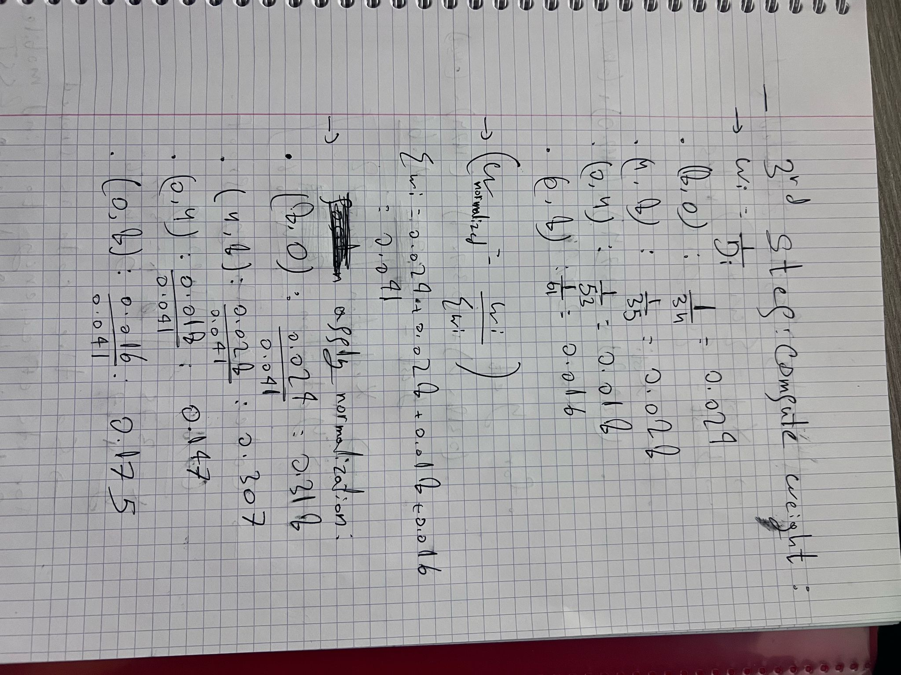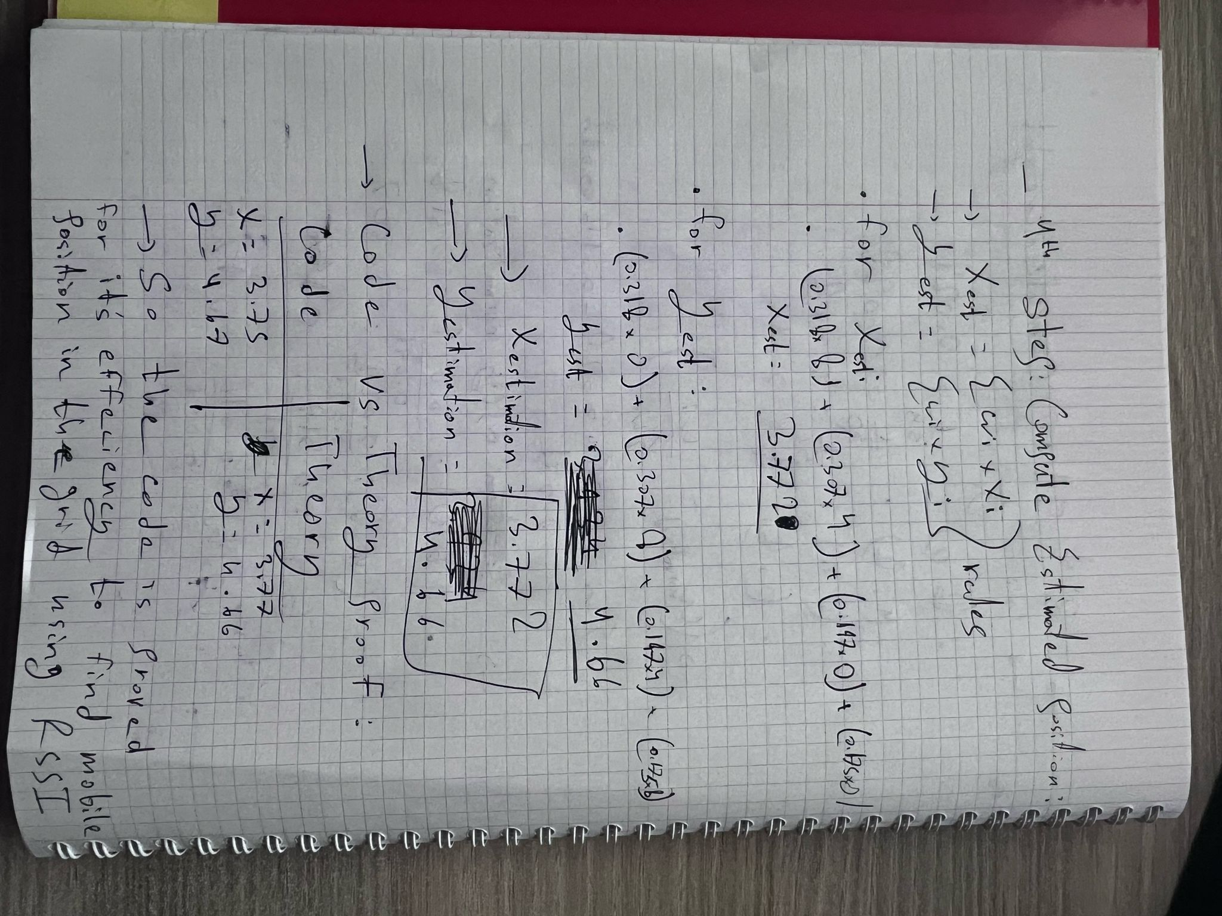

To compare the results obtained from the **code-based fingerprinting localization** and the **theoretical manual calculation**, we can analyze the slight variation in the estimated positions.

The **code output** provides an estimated position of **(x = 3.75, y = 4.67)**, while the **theoretical proof** calculates a slightly different position of **(x = 3.77, y = 4.66)**. This minor discrepancy may arise due to **floating-point approximations, rounding differences, or numerical precision limitations** in the computational approach.

Despite this small variation, the results are very close, indicating that the **RSSI fingerprinting localization algorithm is working accurately and aligns well with the theoretical calculations**. Any further refinements in weight computation or handling of precision errors could further minimize this difference.

Thus, the **fingerprinting-based localization method proves to be effective and reliable**, with only negligible numerical differences between automated and manual calculations.

* Note that:
  + c1​+c2​+...+ck​=1 equation using c2​=(1/α1)​c1, where α=d2/​d1​​ given in class corresponds to Wi​=Wi/∑Wi​ using Wi​=1/Di that i used in my code and theories​​.
  + So we used the given theories in class.

### **Conclusion**

The program successfully estimates the position of the mobile terminal using **RSSI-based fingerprinting localization**. By comparing the results provided by the implementation with the manual theoretical calculations, we find that our program accurately determines the estimated position within the expected search area. The **RSSI similarity method** used effectively selects the **k-nearest reference points**, assigns appropriate weights, and computes a weighted barycentric estimate, aligning well with the theoretical model. Despite minor numerical differences due to rounding or normalization variations, the approach proves to be a reliable method for indoor positioning.